**PEMERINTAH KABUPATEN MALANG   
KECAMATAN TAJINAN**

**DESA NGAWONGGO**

Alamat JI. Suroyudo No.181 Ngawonggo Telp: 085100556353   
No : 111 / 0008/ 35.07.15.2004 / 2024



**FORMULIR KARTU TANDA PENDUDUK (KTP) WARGA NEGARA INDONESIA**

| 35 |  | Jawa Timur |
| --- | --- | --- |
| 07 |  | Malang |
| 15 |  | Tajinan |
| **2004** |  | **Ngawonggo** |

PEMERINTAH PROVINSI

PEMERINTAH KABUPATEN

KECAMATAN

| PERMOHONAN KTP |  | 1. Baru |  |  | 1. Perpanjangan |  |  | 1. Penggantian |
| --- | --- | --- | --- | --- | --- | --- | --- | --- |

DESA

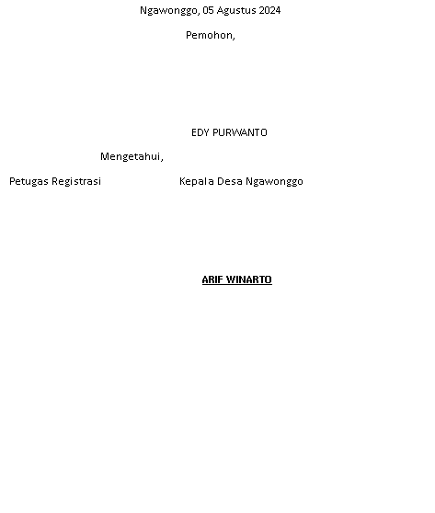

| RT |  |  | RW |  |  | KODE POS |  |
| --- | --- | --- | --- | --- | --- | --- | --- |

| Pas Photo (2x3) | Cap Jempol | Specimen Tanda Tangan |
| --- | --- | --- |
|  |  |  |

| 1. Nama Lengkap |  |  |
| --- | --- | --- |
| 1. No. KK |  |  |
| 1. NIK |  |  |
| 1. Alamat |  |  |

**PEMERINTAH KABUPATEN MALANG   
KECAMATAN TAJINAN**

**DESA NGAWONGGO**

Alamat JI. Suroyudo No.181 Ngawonggo Telp: 085100556353   
No : 111 / 0008/ 35.07.15.2004 / 2024



**FORMULIR KARTU TANDA PENDUDUK (KTP) WARGA NEGARA INDONESIA**

PEMERINTAH PROVINSI

| 35 |  | Jawa Timur |
| --- | --- | --- |
| 07 |  | Malang |
| 15 |  | Tajinan |
| **2004** |  | **Ngawonggo** |

PEMERINTAH KABUPATEN

KECAMATAN

DESA 

| 1. Nama Lengkap |  |  |
| --- | --- | --- |
| 1. No. KK |  |  |
| 1. NIK |  |  |
| 1. Alamat |  |  |

| PERMOHONAN KTP |  | 1. Baru |  |  | 1. Perpanjangan |  |  | 1. Penggantian |
| --- | --- | --- | --- | --- | --- | --- | --- | --- |

| RT |  |  | RW |  |  | KODE POS |  |
| --- | --- | --- | --- | --- | --- | --- | --- |

| Pas Photo (2x3) | Cap Jempol | Specimen Tanda Tangan |
| --- | --- | --- |
|  |  |  |